FOR IMMEDIATE RELEASE Press Statement
1 September 2025
Page 1 of 3

Carlsberg Hong Kong partners with Young Master Brewery for exclusive
distribution rights of the Beer and Ready-to-Drink Range in Hong Kong and Macau

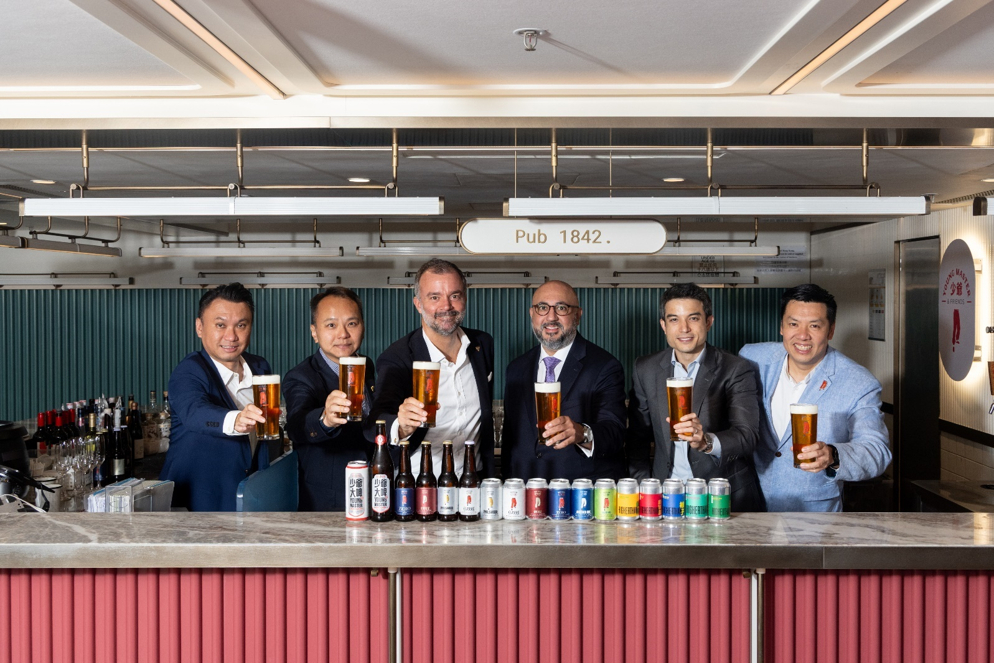

Hong Kong, 1 September 2025 – Carlsberg Brewery Hong Kong Ltd. (“Carlsberg”) announces a strategic partnership with Young Master Brewery (“Young Master”), one of Asia’s most celebrated premium beer producers. Under an exclusive Distributorship Agreement, Carlsberg will oversee the distribution and sales of Young Master’s full portfolio of beers and Ready-to-Drink (“RTD”) products in Hong Kong and Macau, effective September 1, 2025.

Founded in Hong Kong and now enjoyed internationally, Young Master has earned widespread acclaim for its bold flavours, sustainable practices, and dedicated following. From timeless classics to inventive seasonal releases, the brand’s offerings reflect a commitment to quality and creativity that resonates with discerning consumers. Young Master takes pride in its locally brewed beers and celebration of regional cocktail flavours from Salted Lime to Yuzu Gins and Mala Mules.

Asia continues to be a cornerstone of growth for the Carlsberg Group, driving both volume and value across the region. This strategic alliance will expand Carlsberg’s premium portfolio in line with its Accelerate SAIL strategy also unlocks new opportunities for Young Master to scale and deepen its presence in its home-market of Hong Kong and Macau, bringing its award-winning products to a broader audience.

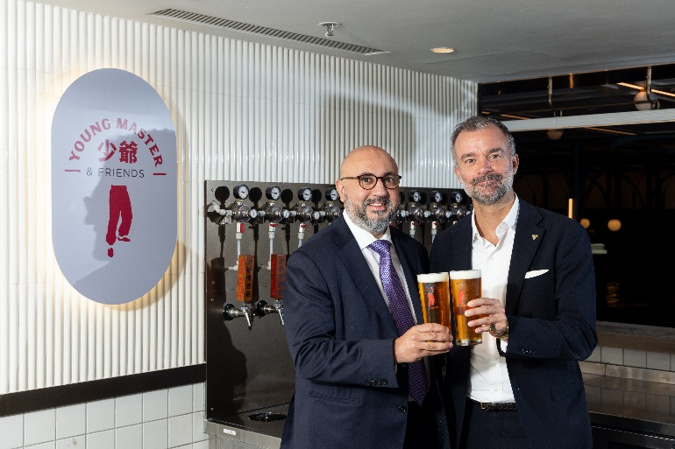 | 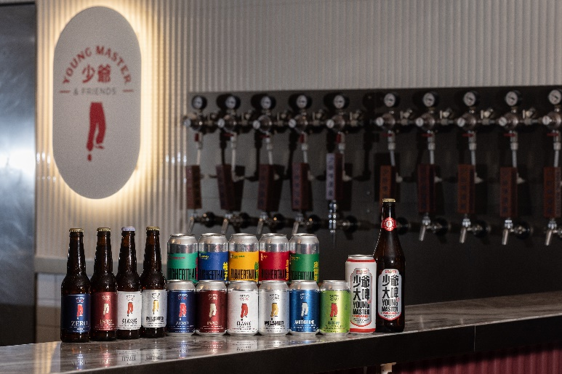

“We are thrilled to collaborate with Young Master, a true champion of local craftmanship, to expand our product offerings in Hong Kong and Macau. This partnership not only complements our company's premium portfolio but also deepens our connection with the vibrant local community,” said Nathaniel Moxom, Managing Director of Carlsberg Hong Kong and Taiwan. “By utilising our extensive distribution network, we are bringing more choices to consumers and elevating the premium beer scene across the region.”

“Young Master takes great pride in our deep-rooted local heritage, and this partnership aligns perfectly with our vision and commitment to delivering premium, locally brewed drinks to the consumers of Hong Kong and Macau. It’s a win for consumers who value quality, convenience, and authenticity.” said Angad Banga JP, Non-Executive Director of Young Master Brewery and Chief Operating Officer of The Caravel Group Ltd

Both Carlsberg and Young Master Brewery are excited to serve consumers at on-trade venues,
including renowned hotels, exclusive members clubs, and trendy restaurants and bars in Hong Kong.
Additionally, Young Master beers and RTD products will be available at specialty stores and upscale supermarkets. More information about Young Master Beer products and promotions will be available on Carlsberg’s official website and Young Master’s social media channels starting September 2025.

– End –

For media inquiries, please contact:

Carlsberg Brewery Hong Kong Limited
Sindy Wong
Senior Manager, Corporate Affairs and Engagement, Asia
Email: sindy.sy.wong@carlsberg.asia
Phone: +852 9862 1072

Young Master Brewery
Ashley Tam
Senior Marketing Manager
Email: Ashley@youngmasterales.com
Phone: +852 2783 8907

About Carlsberg Brewery Hong Kong Limited

Founded in 1847 by brewer J.C. Jacobsen, Carlsberg has grown into one of the world’s leading brewery groups, boasting an extensive portfolio of beer and beverage brands across 150 markets and employing 37,000 staff globally. Carlsberg Brewery Hong Kong Limited offers a diverse range of beers, including Carlsberg, 1664, Somersby, and SKOL.

With a rich tradition spanning 178 years, Carlsberg is driven by a spirit of innovation, curiosity, and an unwavering commitment to progress. The company is dedicated to brewing for a better today and tomorrow, continuously striving to enhance its offerings and foster a sustainable future.

https://carlsberghongkong.com.hk/en/

About Young Master Brewery
Young Master Brewery, founded in 2013, is dedicated to brewing high-quality beers that capture the unique essence of Hong Kong and Asia. Renowned for its distinctive brews that marry tradition with creativity and uncompromising commitment to excellence, Young Master has grown into one the most beloved craft breweries in Asia.

Based in Hong Kong, Young Master quickly established itself as one of Asia’s most acclaimed craft breweries, celebrated for its commitment to quality, innovation and local craftsmanship. Its award-winning portfolio, including HIGHERTHAN and Young Master Grand, spans from timeless lagers and ales to boundary-pushing experimental brews, each inspired by the vibrant culture and flavors of the region. The brewery prioritizes sustainable practices and community engagement, fostering a loyal following among beer enthusiasts. As a pioneer of Asia’s craft beer movement, Young Master continues to expand its reach across Asia, delivering world-class yet locally rooted beer experiences that resonate with consumers’ evolving tastes.

www.youngmasterales.com

